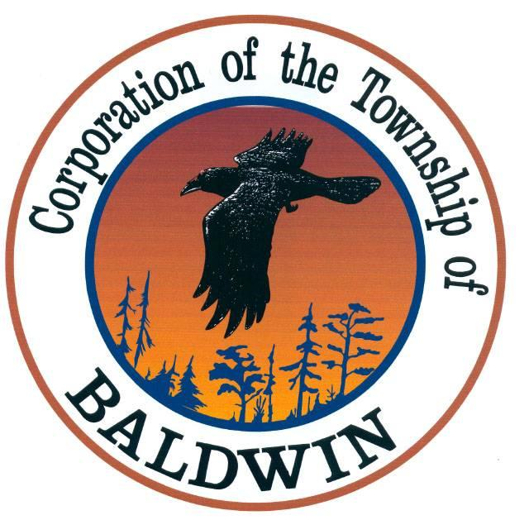
The Corporation of the
TOWNSHIP OF BALDWIN
P.O. Box 7095, 11 Spooner Street
MCKERROW, ONTARIO
P0P 1M0

TEL: (705) 869-0225 FAX: (705) 869-5049
______________________________________________________________________________
TOWNSHIP OF BALDWIN
Regular Meeting of Council
MINUTES
DATE: June 14, 2021
TIME: 6:30 pm
PLACE: ZOOM

- Call to Order & Note Members Present
The meeting was called to order by the Mayor at 6:30 p.m.

Council members present: Mayor Gorham
Deputy Mayor Boucher
Councillor Maltais
Councillor McDowell
Councillor Fairbairn
Other: Sarah Vereault, J L Richards
Texas MacDonald
Clerk - Karin Bates
- Declaration of Pecuniary Interest and The General Nature Thereof – None

- Agenda

NOW THEREFORE BE IT RESOLVED THAT: the agenda for the Regular Council Meeting be accepted as presented.

Resolution #21-46
Moved: Maltais
Second: Boucher CARRIED

- Minutes – Business Arising from Minutes

NOW THEREFORE BE IT RESOLVED THAT: the minutes from the Regular Council Meetings of May 10th, 2021, are hereby accepted.

Resolution #21-47
Moved: Fairbairn
Second: McDowell CARRIED

5. Delegations & Petitions
a) Consent Application – Fletcher (Sara Vereault, J.L. Richards present)

NOW THEREFORE BE IT RESOLVED THAT: Council approves provisional consent to create a new lot to be developed for residential purpose. PT LT 4 CON 2 BALDWIN, BEING PTS 1, 2 & 3 53R-19147, 19 HIGGINS ROAD. Consent is subject to the conditions on the “Notice of Decision” being fulfilled within a one-year period from the date of this decision.

Resolution #21-48

Moved: Maltais
Second: Fairbairn CARRIED

b) New Mailboxes – Addresses

DIRECTION: Clerk to supply Canada Post with the original 911 numbers list for civic addresses for the new mailboxes, which includes the 0 at the front of the number.

6. REPORTS
  - Staff
    - Fire Chief – see report
    - Roads Report
    - CAO/Clerk-Treasurer – see report

  - Councillors
    - Roads Liaisons
    - Recreation Liaison
    - Fire Liaison

  - Mayor

  - Building Inspector

NOW THEREFORE BE IT RESOLVED THAT: The reports be accepted as read.

Resolution #21-49
Moved: Boucher
Second: McDowell CARRIED

7. Correspondence
1) Public Health Sudbury & Districts – Unapproved Minutes
2) 2021 Hazardous Waste Day Report – Town of Espanola
3) Manitoulin-Sudbury District Services Board – Financials 2020
4) Prime Minister – email re: ban to certain models of assault firearms
5) FONOM – Media Release
6) Ministry of Municipal Affairs – Three-Step Roadmap to Safely Reopen Province
7) Police Services Board Report – Baldwin
8) LaCloche Foothills – Municipal Councillor Code of Conduct Consultations
9) LaCloche Foothills Municipal Association – Community Safety & Well Being Facilitator

NOW THEREFORE BE IT RESOLVED THAT: the correspondence is hereby accepted as circulated and/or read.

Resolution #21-50

Moved: Fairbairn
Seconded: Maltais CARRIED

- STATEMENT OF ACCOUNT

NOW THEREFORE BE IT RESOLVED THAT: Purchase Journal 2021-05 in the amount of $ 66,556.11 be accepted.
Resolution #21-51

Moved: Boucher
Seconded: McDowell CARRIED

- By-Laws & Resolution:

1) OPP Police Services Board amendment

NOW THEREFORE BE IT RESOLVED THAT: Resolution 2021-40 be amended to reflect that the Township of Baldwin would be in favour of the proposed 8 member Police Services Board for our O.P.P. Detachment area.

Resolution #21-52
Moved: Fairbairn
Seconded: Boucher CARRIED

2) Corporation of the Municipality of Calvin – “Dead-End Road delegation”.

NOW THEREFORE BE IT RESOLVED THAT: Council supports Resolution No. 2021-137 from the Corporation of the Municipality of Calvin regarding students being picked up by school busses on dead end roads (cul-de-sacs, private roads).

Resolution #21-53

Moved: Maltais
Seconded: Fairbairn CARRIED

3) By-Law 2014-A-004 – Minimum Road Standards – amended

NOW THEREFORE BE IT RESOLVED THAT: Council supports amending By-Law 2014-A-004 – Being a By-Law to establish minimum maintenance standards for municipal roadways to include d. Parking iii. No person shall at any time park a vehicle on a sidewalk or Boulevard on Highway 17.

Resolution #21-54

Moved: Boucher
Seconded: McDowell

New By-Law # 2021-A-001

4) Municipality of Grey Highlands – insurance increases

NOW THEREFORE BE IT RESOLVED THAT: Council supports Resolution #2021-39 from Municipality of Grey Highlands regarding continuous increases of cost for municipal insurance.
Resolution #21-55

Moved: Maltais
Seconded: Fairbairn CARRIED

5) Amend By-Law 750 – Council Meeting time change

NOW THEREFORE BE IT RESOLVED THAT: Council supports amending By-Law 750 Being a By-Law to provide the Adoption of Rules and Procedures for the Municipal Council of the Corporation of the Township of Baldwin to reflect the time change for Council Meetings to 5:00 p.m, every second Monday of the month, unless otherwise posted.

Resolution #21-56
Moved: Fairbairn
Seconded: McDowell CARRIED

DIRECTION: Clerk to change the time of regular council meetings to 5:00 p.m. It was noted that this is on a temporary basis to ensure it does not interfere with residents being able to attend the meetings.

10. In-Camera
NOW THEREFORE BE IT RESOLVED THAT: Pursuant to section 239 (2), (3) of the Municipal Act 2001 as amended, Council will now go into closed session to discuss legal matters and employees.

TIME: 7:03 p.m.

Resolution #21-57

Moved: Boucher
Seconded: McDowell CARRIED

NOW THEREFORE BE IT RESOLVED THAT: Pursuant to section 239 (2), (3) of the Municipal Act 2001 as amended, Council will now go out of closed session.

TIME: 7.18 p.m.

Resolution #21-58
Moved: Maltais
Seconded: McDowell CARRIED

DIRECTION FROM IN CAMERA MEETING: Clerk to contact legal counsel regarding By-Law 2019-P-001. Being a By-Law to provide for the regulation and prohibition of unusual noises for noises likely to disturb the public and for the prevention of public nuisances.

Next meeting will be held on September 13th, 2021 – 5:00 p.m.

11. Close of Meeting:

Motion to adjourn. TIME: 7:19 p.m.

_____________________________ ________________________________
MAYOR CLERK

