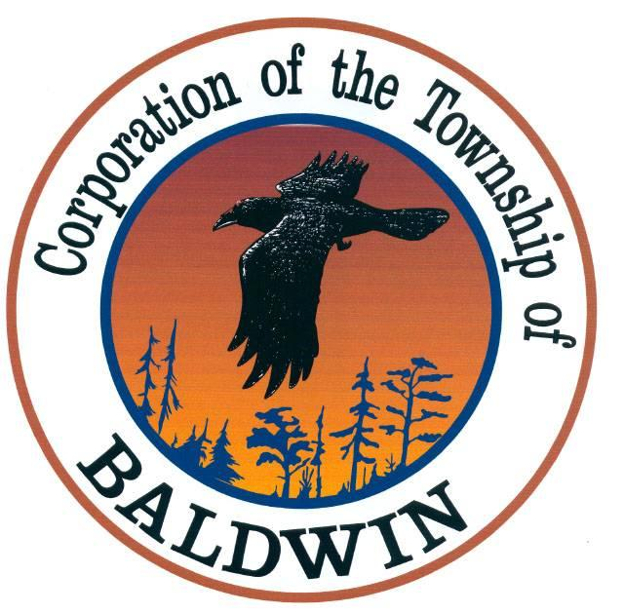
The Corporation of the
TOWNSHIP OF BALDWIN
P.O. Box 7095, 11 Spooner Street
MCKERROW, ONTARIO
P0P 1M0

TEL: (705) 869-0225 FAX: (705) 869-5049
______________________________________________________________________________
TOWNSHIP OF BALDWIN
Regular Meeting of Council
MINUTES
DATE: October 18th, 2021
TIME: 5:00 pm
PLACE: Council Chambers

- Call to Order & Note Members Present
The meeting was called to order by the Mayor at 5:00 p.m.

Council members present: Mayor Gorham
Councillor Maltais
Councillor McDowell
Councillor Fairbairn
Other: Bill Land, Delegation & Petitions
Fire Chief – Bob Clement
Clerk - Karin Bates
Absent: Deputy Mayor Boucher

- Declaration of Pecuniary Interest and The General Nature Thereof – none

- Agenda

NOW THEREFORE BE IT RESOLVED THAT: the agenda for the Regular Council Meeting be accepted as presented.

Resolution #21-75
Moved: McDowell
Second: Fairbairn CARRIED

- Minutes – Business Arising from Minutes
a) Minutes

NOW THEREFORE BE IT RESOLVED THAT: the minutes from the Regular Council Meeting of September 13th, 2021, are hereby accepted.

Resolution #21-76
Moved: Faribairn
Second: McDowell CARRIED

5. Delegations & Petitions

- Bill and Sue Land – Culvert
DIRECTION: Council agrees to replace the culvert which is causing drainage issues on Hardwood Road, following an inspection by Roger Hannon & Councillor Maltais verifying that is has collapsed.

6. REPORTS
  - Staff
    - Fire Chief

    - Roads Report

    - CAO/Clerk-Treasurer

  - Councillors
    - Roads Liaisons
    - Recreation Liaison
    - Fire Liaison

  - Mayor

  - Deputy Mayor

  - Building Inspector – review set fines DB
DIRECTION: Clerk to prepare set fine documents for approval/review at November Council Meeting. Continue to provide updates with ongoing permit information to Council.

NOW THEREFORE BE IT RESOLVED THAT: The reports be accepted as read.

Resolution #21-77
Moved: McDowell
Second: Fairbairn CARRIED

7. Correspondence
1) MMAH – Ontario Proof of Vaccination Guidance for Businesses and Organizations
2) MMAH – More Homes, More Choice Act 2019
3) COVID Passport - meeting information
4) MSDSB – 2021 Second Quarterly Activity Report
5) Public Health Sudbury and District – facilities responsibilities
6) OPP – Police Services Board Report for Baldwin
7) MSDSB - support

NOW THEREFORE BE IT RESOLVED THAT: the correspondence is hereby accepted as circulated and/or read.

Resolution #21-78

Moved: Fairbairn
Seconded: McDowell CARRIED

- STATEMENT OF ACCOUNT

NOW THEREFORE BE IT RESOLVED THAT:
Purchase Journal 2021-09 in the amount of $118,149.14 be accepted.
Resolution #21-79

Moved: McDowell
Seconded: Fairbairn CARRIED

- By-Laws & Resolution:
1) FONOM – LAND TRANSFER INFRASTRUCTURE SUPPORT

NOW THEREFORE BE IT RESOLVED THAT: Council supports FONOM’s resolution pertaining to Land Transfer Infrastructure Support (LTIS) from September 23, 2021.

Resolution #21-80

Moved: McDowell
Seconded: Fairbairn CARRIED

2) RAINBOW DISTRICT – BY-LAW ENFORCEMENT PROPOSAL

DIRECTION: Put in a 5-year clause stating that the yearly increase will only be the CPI increase. Also indicating that we can opt out, without penalty at the end of the year if Council is not satisfied with the agreement. Bring back next meeting.

3) PRO SONICS – ACOUSTIC TREATMENT OF RECREATION BUILDING

DIRECTION: Can they match the colour of tiles. Guarantee we will be down to a 1 of noise reduction. Bring back to November Meeting

4) MSDSB Support -of Resolution 21-83 - Northern Ontario Health Teams

WHEREAS Communities across the province are addressing an intensified social crisis and Northern Ontario is no different. We recognize that creating solutions will require a multi-ministry approach but if there are lessons to be learned from this pandemic, what were once cracks in the health care foundation, there are now large gaps forming especially around mental health, addictions, and homelessness;

WHEREAS Northern Ontario has significant challenges when it comes to accessing mental health and addictions services for our people in our communities;

WHEREAS over 300 Child care staff who provide services to over 21,000 licenced child care spaces in over 340 locations across the North and they see the effects of Mental Health and Addictions every day in the children they care for and the parents they support;

WHEREAS, the defined area of Northern Ontario is over 800,000 square kilometres. Also, annually over 500 Social Services staff provide financial and employment assistance to over 15,000 families in 37 delivery sites across the North. Over 300 Community Housing staff provide safe and affordable housing to over 17,000 families in the North. In addition, there are many Police Officers and over 900 paramedics who responded to 200,000 medical emergency 911 calls. Paramedics have seen the direct results of the Mental Health and Addictions crisis in the North and some cases becoming ill themselves trying to cope with what they have seen;

WHEREAS The Township of Baldwin appreciates the efforts of all the agencies that are working to help and support those addicted to opioids. In some districts, over 30 agencies are providing some assistance. But we would like to see consolidation of these agencies with the input of Municipalities/DSSAB’s and local stakeholders. As we believe, a streamlined agency would be able to put the combined funds to better use;

THEREFORE BE IT RESOLVED THAT The Township of Baldwin ask that our Northern Ontario Health Teams, in consultation with Municipalities/DSSAB’s and local stakeholders, support a province-wide strategy that supports such consolidation;

FUrTHER BE IT RESOLVED THAT a copy of this Resolution to be shared with Premier Ford, Christine Elliott the Minister of Health, Michael Tibollo the Associate Minister of Mental Health and Addictions, the Leaders of the Provincial Oppositions, and the Association of Municipalities of Ontario (AMO).

Resolution #21-81

Moved: McDowell
Seconded: Fairbairn CARRIED

5) 2021-A-004 STAFF AND EMPLOYEE POLICY

DIRECTION: Bring back to November Council meeting as Deputy Mayor Boucher was absent and had some concerns regarding this Resolution.

6) BY-LAW 2021-A-003 – AMENDMENT (see page 13)

Resolution #21-82

NOW THEREFORE BE IT RESOLVED THAT: Council passes amendment to
By-Law 2021-A-003. A By-Law to provide for the Adoption of Rules and
Procedure for the Municipal Council of the Corporation of the Township of
Baldwin.

Moved: Fairbairn
Seconded: McDowell CARRIED

8) TENDER – HOUSE DEMO

NOW THEREFORE BE IT RESOLVED THAT: Council approve tender application pertaining to House Demolition – 2 Hardwood Road received from LaCroix in the amount of $14,690.00.

Resolution #21-83

Moved: Fairbairn
Seconded: McDowell CARRIED

- In-Camera
Legal and Staffing
NOW THEREFORE BE IT RESOLVED THAT: Pursuant to section 239 (2), (3) of the Municipal Act 2001 as amended, Council will now go into closed session to discuss legal and employees.

TIME: 5:50 p.m.

Resolution #21-84

Moved: Fairbairn
Seconded: McDowell CARRIED

NOW THEREFORE BE IT RESOLVED THAT: Pursuant to section 239 (2), (3) of the Municipal Act 2001 as amended, Council will now go out of closed session.

TIME: 6:05 p.m.

Resolution #21-85

Moved: Fairbairn
Seconded: McDowell CARRIED

11. Close of Meeting:

Motion to adjourn - Maltais TIME: 6:06 p.m.

_____________________________ ________________________________
MAYOR CLERK

