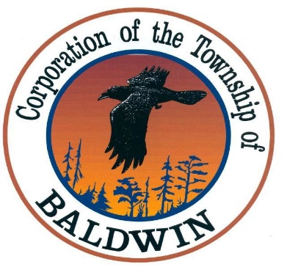
The Corporation of the
TOWNSHIP OF BALDWIN
P.O. Box 7095, 11 Spooner Street
MCKERROW, ONTARIO
P0P 1M0

TEL: (705) 869-0225 FAX: (705) 869-5049
______________________________________________________________________
TOWNSHIP OF BALDWIN
Regular Meeting of Council
MINUTES
DATE: October 14th, 2025
TIME: 5:00 pm
PLACE: Baldwin Township Municipal Hall

CALL TO ORDER & NOTE MEMBERS PRESENT
The meeting was called to order by the Mayor at 5:00 p.m.

Council members present:
Mayor Vern Gorham
Deputy Mayor Jason Cote
Councilor Bert McDowell
Councilor Marc Lepine
Councilor Ray Maltais

Staff present:
Clerk Holly Zahorodny

Regrets:
NONE

Declaration of Pecuniary Interest and the General Nature Thereof:
Vern Gorham – Section 10.1

MEETING OPEN
Resolution # 25-138
Moved by: M. Lepine
Seconded by: B. McDowell

NOW THEREFORE BE IT RESOLVED THAT: The October 14th, 2025 Council meeting is now open at 5:00 p.m.

CARRIED

AGENDA
Resolution # 25-139
Moved by: M. Lepine
Seconded by: J. Cote

NOW THEREFORE BE IT RESOLVED THAT: The council accepts the October 14th, 2025 agenda as presented, section 3.

CARRIED

COUNCIL MINUTES
Resolution #25-140
Moved by: J. Cote
Seconded by: B. McDowell

NOW THEREFORE BE IT RESOLVED THAT: The council accepts the meeting minutes as presented, section 4.

CARRIED

DELEGATIONS
  - KBL – Economic Development Presentation
  - Melissa Claydon – Baldwin Recreation Committee

REPORTS
Resolution #25-141
Moved by: M. Lepine
Second by: J. Cote

NOW THEREFORE BE IT RESOLVED THAT: The Council accepts the October 14th, 2025 Reports as presented in section 6.

CARRIED

CORRESPONDENCE
Resolution #25-142
Moved by: B. McDowell
Second by: M. Lepine

NOW THEREFORE BE IT RESOLVED THAT: The Council accepts the correspondence as presented, section 7.

STATEMENT OF ACCOUNTS
Resolution # 25-143
Moved by: B. McDowell
Second by: J. Cote

NOW THEREFORE BE IT RESOLVED THAT: The council accepts the October 14th, 2025 Statement of Accounts as presented, section 8.

CARRIED

RESOLUTIONS
Resolution # 25-144
Moved by: M. Lepine
Second by: R. Maltais

NOW THEREFORE BE IT RESOLVED THAT: Council support the Corporation of the Township of McGarry resolution #267/2025 urging the Government of Ontario to make the Northern Ontario Resource Development Support (NORDS) program a permanent fixture of its support to Northern Municipalities.

CARRIED

BY-LAWS
Resolution # 25-145
Moved by: M. Lepine
Second by: J. Cote

NOW THEREFORE BE IT RESOLVED THAT: Being a by-law to prohibit or regulate the parking of vehicles in the Corporation of the Township of Baldwin be hereby accepted and put into effect on this 14th day of October, 2025.

CARRIED

OTHER BUSINESS
Resolution # 25-146
Moved by: M. Lepine
Second by: B. McDowell

NOW THEREFORE BE IT RESOLVED THAT: Council accepts the Clerks request to have item 11.2 regarding the Validation of Title for Part of lot 7, Concession 1 in the Township of Baldwin be added to the agenda.

CLOSED SESSION
NONE

MEETING CLOSED
Resolution # 25-147
Moved by: R. Maltais
Second by: M. Lepine

NOW THEREFORE BE IT RESOLVED THAT: The October 14th, 2025 Council meeting is now adjourned at 7:00pm.

CARRIED

______________________ ______________________
Mayor Clerk

